Forecasting the climate response due to anthropogenic greenhouse emissions

*Durham University, Physics Department*

*Thomas Davies*

*January 2024*

It is a long established fact that a reader will be distracted by the readable content of a page when looking at its layout. The point of using Lorem Ipsum is that it has a more-or-less normal distribution of letters, as opposed to using 'Content here, content here', making it look like readable English. Many desktop publishing packages and web page editors now use Lorem Ipsum as their default model text, and a search for 'lorem ipsum' will uncover many web sites still in their infancy. Various versions have evolved over the years, sometimes by accident, sometimes on purpose (injected humour and the like).

*Table of Contents*

1. *Introduction ……………………………… 1-3*

**Motivation**

In the last 250 years our species has been subject to various technological transformations; the most relevant being the industrial and digital revolutions.

The 1700s ushered in the industrial revolution*[1]*, where industry and machine manufacturing dominated the British landscape. It was during this era that coal was heavily utilised as a fuel source, burning it enabled us to power the production machinery that populated the factories, as well as the piston engine that allowed transportation of goods and people across the globe. More recently, we have seen the mass proliferation of electricity within or society; it is utilised everywhere from operating our power plants to controlling the appliances within our homes.

As can be seen inthe figure below, the mass adoption of coal as a fuel source during the industrial revolution has created an upwards trend in the carbon dioxide concentration present within our atmosphere.

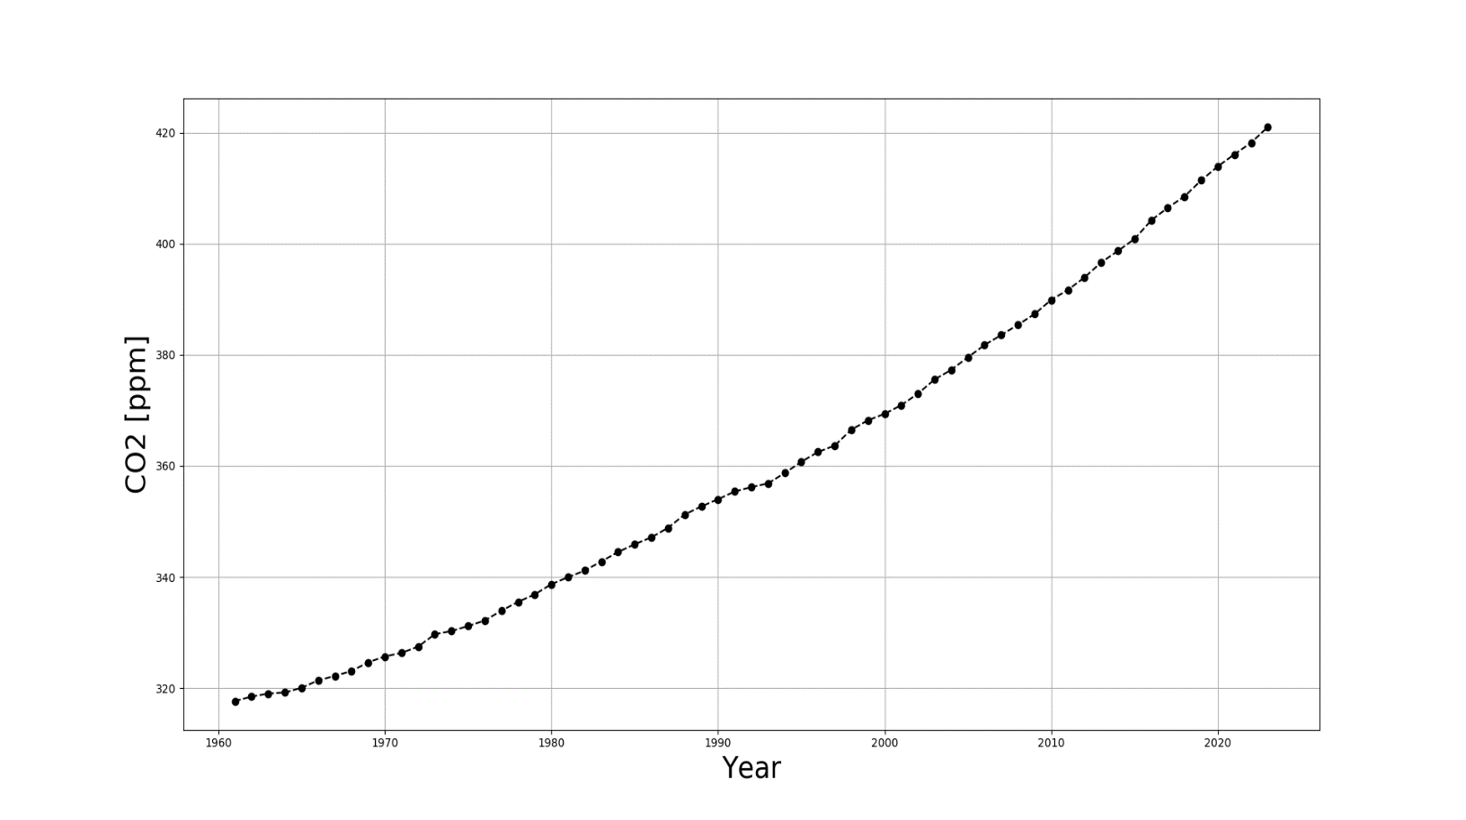

*[Figure 1. A plot of CO2 concentration (ppm) within Earth’s atmosphere, from 1961-2023.]*

Earth absorbs energy from the sun and re-radiates some of this energy back towards the atmosphere. The radiation can pass through the atmosphere into outer space, or interact with the atmosphere and get reflected back to Earth’s surface.

We now know that carbon dioxide has an insulting effect on the plant’s climate; that is to say that it increases the likelihood that radiation will be reflected back towards the plant’s surface, instead of escaping into outer space. Therefore, the consequence of a high carbon dioxide concentration within the atmosphere, will be an increase in global average temperature due to the increase in trapped radiation from the sun.

The figure below shows observations of the global average temperature dating back to the 17th century; we can see that the data is consistent with what we would expect given the increase in atmospheric CO2 concentrations that we have observed over this time period.

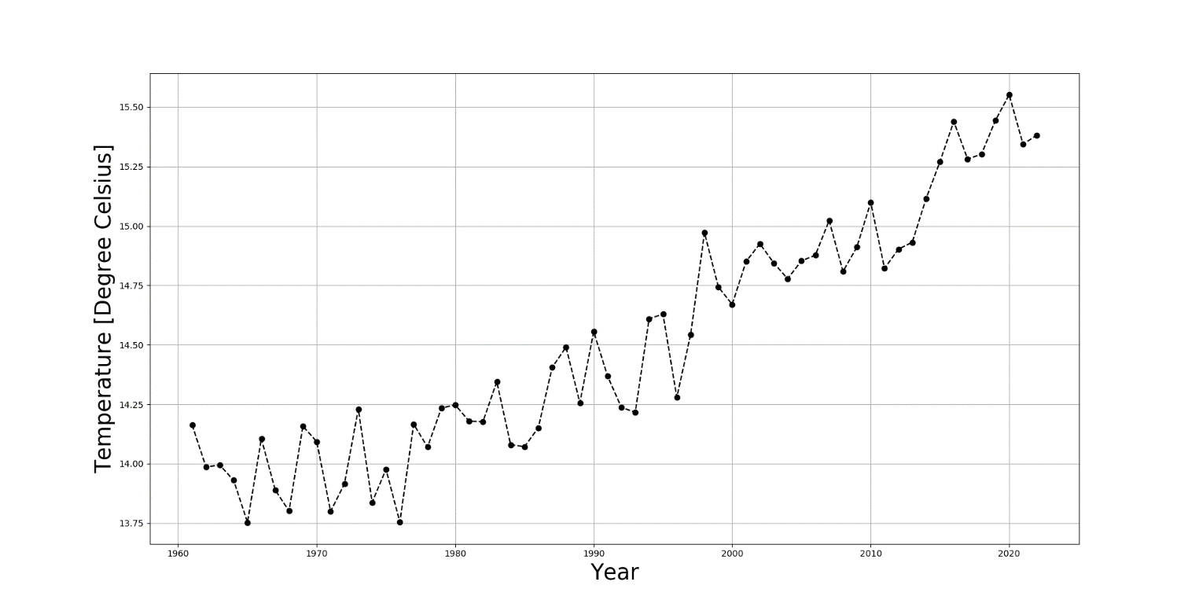

*[Figure 2. A plot of the absolute global average temperature (degrees Celsius) from 1960-2023.]*

An increase in frequency of more severe weather events; melting of the polar ice caps, causing low-altitude land masses to be submerged, and possible extinction of certain animals are all likely repercussions of a warmer global climate.

Looking ahead, we can safely say that the demand for energy isn’t slowing down; in-fact it will only increase. Developing nations are constantly increasing their energy consumption as they catch up to the more developed; our current digital infrastructure that enables the internet and other digital services to function will require more investment and energy over the coming years; and the cutting-edge technologies of today such as artificial intelligence and electric vehicles, will ensure that the demand for energy within the future will only continue to increase.

We understand now that burning coal and other fossil fuels that pollute our atmosphere with greenhouse gasses isn’t sustainable, due to their limited nature and negative impact they have on the planet. The rate at which we wean ourselves off of these types of fuels will determine to what degree our planet will heat up over the coming decades, and thus how we will be affected by the repercussions of these greenhouse gasses.

The aim of this research is to develop a simplified computational model of Earth’s climate that can reproduce the observed trend in global average temperature, and then project the global temperature into the future, for a given CO2 projection; allowing us to understand if the current attitude towards these fuels is aggressive enough in order to prevent our climate warming to a dangerous, life-threatening level.